**TABLES**

**Introducing Tables:**

Tables display information in rows and columns; they are commonly used to display all manner of data that fits in a grid such as train schedules, television listings, financial reports, and sports results. In order to work with tables, you need to start thinking in *grids,* so let’ s start off by looking at some examples of how popular web sites use tables.

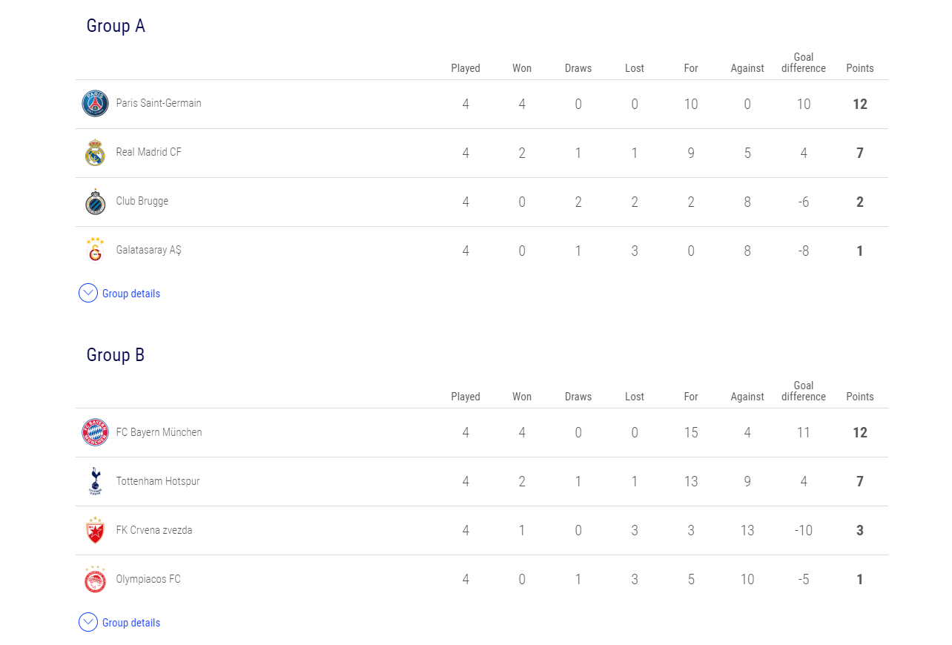

Figure: Uefa Champions League Table

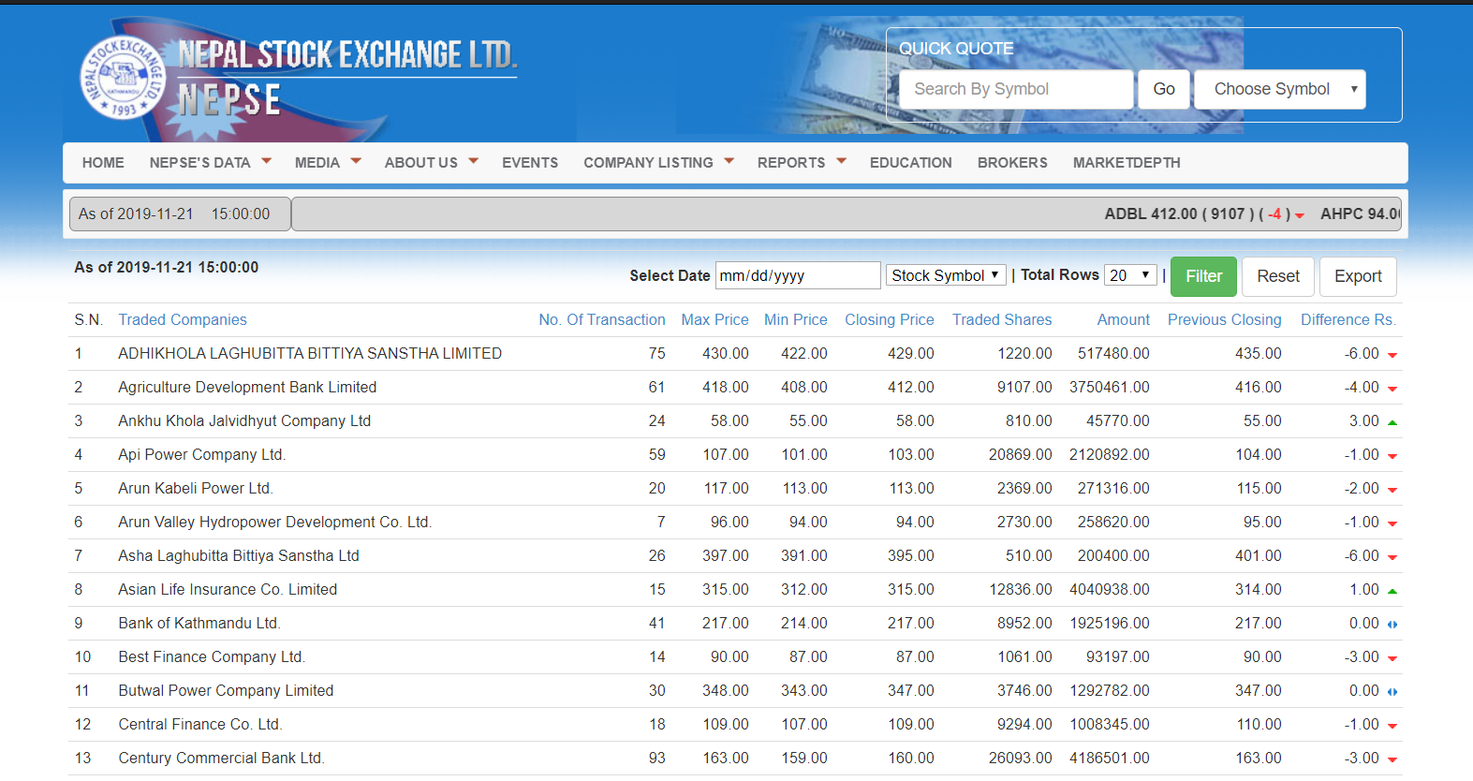

Figure: Share Price Table

You can think of a table as being very similar to a spreadsheet because it is made up of rows and columns, as shown in figure below:

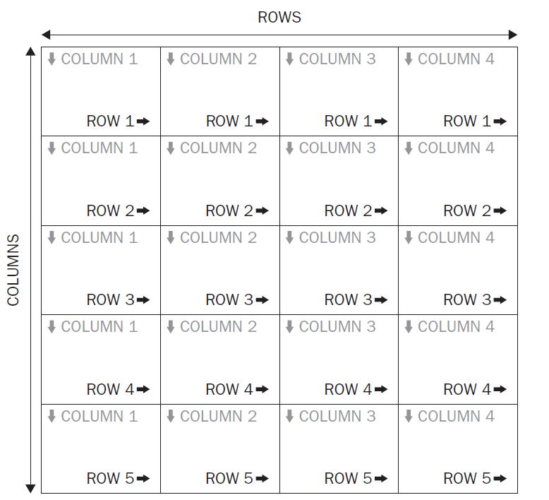

Here you can see a grid of rectangles. Each rectangle is known as a *cell.* A *row* is made up of a set of cells on the same line from left to right, and a *column* is made up of a line of cells going from top to bottom.

Basic syntax of table:

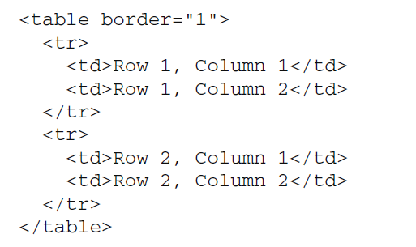

Note: Each table must be represented by either a <td> or a <th> element in order for the table to display correctly, even if there is no data in that cell. When creating tables, many people do not actually bother with the <th> element and instead use the <td> element for every cell — including headers. You should, however, aim to use the <th> element whenever you have a table heading.

Example/Source Code:

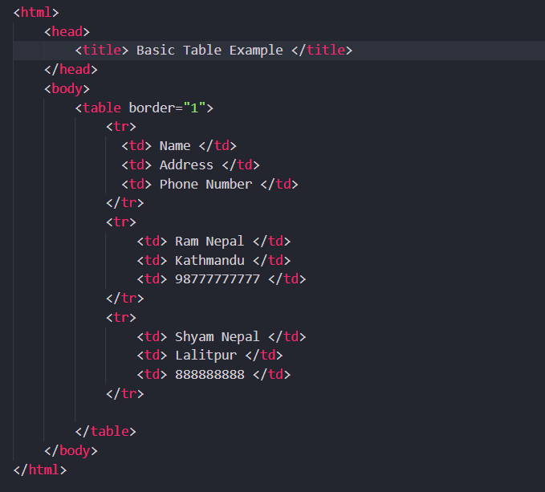

Output:

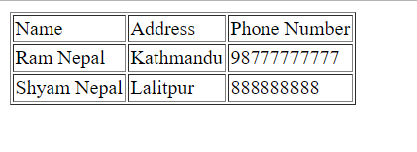

**Basic Table Elements and Attributes:**

Now that you’ ve seen how basic tables work, this section describes the elements in a little more detail, introducing the attributes, they can carry. Some of the attributes allow you to create more sophisticated table layouts. Feel free to skim through this section fairly quickly; once you know what is possible to do with the markup, you can always come back again and study the markup more closely in order to see how to achieve what you want.

**The <table> Element Creates a Table:**

The <table> element is the containing element for all tables. It can carry the following attributes:

* All the universal attributes
* Basic event attributes for scripting

The <table> element can carry the following deprecated attributes. Even though they are deprecated, you will still see many of them in use today: (Explain these attributes on your own)

1. align
2. bgcolor
3. border
4. cellpadding
5. cellspacing
6. dir
7. frame
8. rules
9. summary
10. width

**The <tr> Elements contains Table Rows:**

The <tr> element is used to contain each row in a table. Anything appearing within a <tr> element should appear on the same row. It can carry five attributes, three of which have been deprecated in favor of using CSS.

Attributes: (Explain these)

1. align
2. bgcolor
3. Char
4. Charoff
5. valign

**The <td> and <th> Elements Represent Table Cells:**

Every cell in a table will be represented by either a <td> element for cells containing table data or a <th> element for cells containing table headings. By default, the contents of a <th> element are usually displayed in a bold font, horizontally aligned in the center of the cell. The content of a <td> element, meanwhile, will usually be displayed left – aligned and not in bold (unless otherwise indicated by CSS or another element).

The <td> and <th> elements can both carry the same set of attributes, and the attribute only applies to that one cell carrying it. Any effect these attributes have will override settings for the table as a whole or any containing element (such as a row).

In addition to the universal attributes and the basic event attributes, the < td > and < th > elements can also carry the following attributes:

1. abbr
2. align
3. axis
4. bgcolor
5. Char
6. Charoff
7. colspan
8. headers
9. height
10. nowrap
11. rowspan
12. scope
13. valign
14. width

**Adding a <caption> to a Table:**

Whether your table shows results for a scientific experiment, values of stocks in a particular market, or what is on television tonight, each table should have a caption so that visitors to your site know what the table is for. Even if the surrounding text describes the content of the table, it is good practice to give the table a formal caption using the <caption> element. By default, most browsers will display the contents of this element centered above the table.

The <caption> element appears directly after the opening <table> tag; it should come before the first row:

<table>

<caption> Opening hours for the Example Cafe </caption>

<tr>………

</tr>

</table>

By using a <caption> element, rather than just describing the purpose of the table in a previous or subsequent paragraph, you are directly associating the content of the table with this description — and this association can be used by screen readers and by applications that process web pages (such as search engines).

**Grouping Sections of a Table:**

In this section, you are going to look at some techniques that allow you to group together cells, rows, and columns of a table, and learn the advantages that doing this can bring. In particular, you will see how to do the following:

* Use the rowspan and colspan attributes to make cells stretch over more than one row or column
* Split a table into three sections: a head, body, and foot
* Group columns using the <colgroup> element
* Share attributes between unrelated columns using the <col> element

**Refer to the code file:**

Spanning Rows Using the rowspan Attribute

Spanning Columns Using the colspan Attribute

**Splitting Up Tables Using a Head, Body, and Foot:**

There are occasions when you may wish to distinguish between the body of a table (where most of the data is held) and the headings or maybe even the footers. For example, think of a bank statement: you may have a table where the header contains column headings, the body contains a list of transactions, and the footer contains the balance in the account.

If the table is too long to show on a screen, then the header and footer might remain in view all the time, while the body of the table gains a scrollbar. Similarly, when printing a long table that spreads over more than one page, you might want the browser to print the head and foot of a table on each page. Unfortunately, the main browsers do not yet support these ideas.

However, if you add these elements to your tables, you can use CSS to attach different styles to the contents of the <thead>, <tbody> , and <tfoot> elements.

The three elements for separating the head, body, and foot of a table are:

* <thead> to create a separate table header
* <tbody> to indicate the main body of the table
* <tfoot> to create a separate table footer

A table may also contain several < tbody> elements to indicate different “pages,” or groups of data.

Example/Source Code:

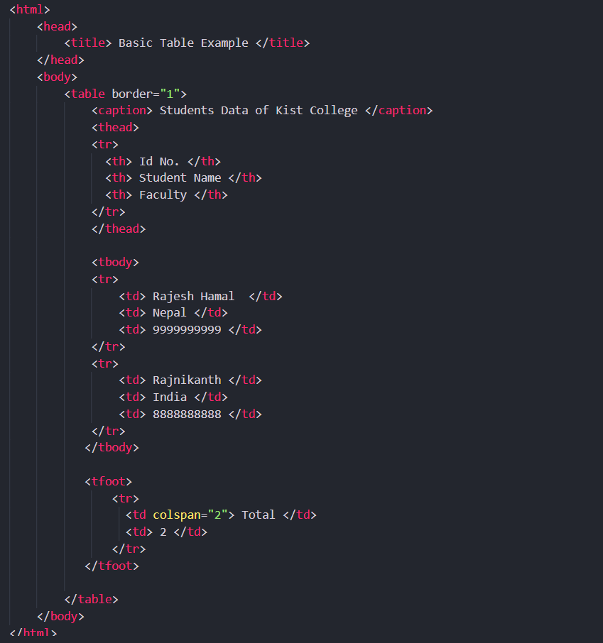

Output:

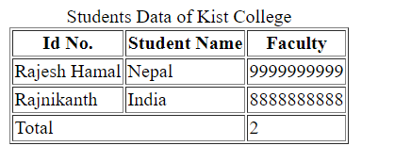

**Refer to the code file:**

Grouping Columns Using the <colgroup> Element

Columns Sharing Styles Using the <col> Element

**Nested Tables:**

As mentioned earlier in the chapter, you can include markup inside a table cell, as long as the whole element is contained within that cell. This means you can even place another entire table inside a table cell, creating what’ s called a *nested table.*

Example/Source Code:

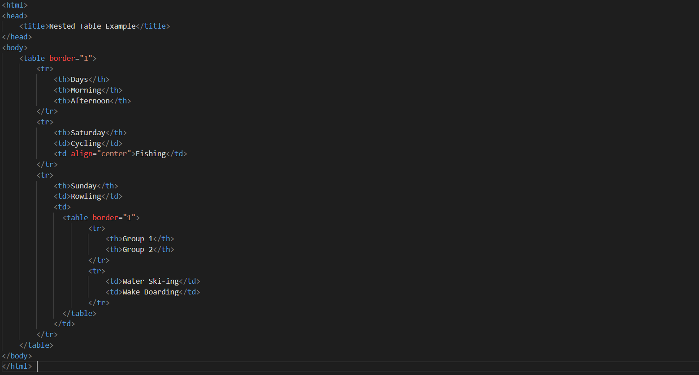

Output:

